Ocean hotel provides you with the comfort you need and the most enjoyable stay. our Location is in Um – Uthaina (25 minutes) away from Q.A.I.A airport and (10 minutes) away from down town.Ocean hotel is a three stars, but very luxurious for its atmosphere and service count. In our lobby where luxury is accompanied with the friendly atmosphere, we make youfeel that you never left your home. At our stylish designed reception you will find all the services you looking for. Our friendly staff will be more than happy to assist you and look for your comfort.
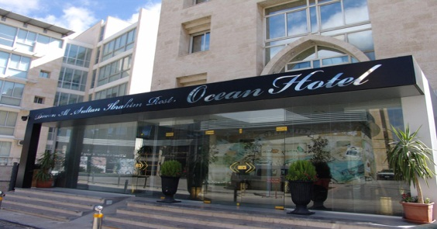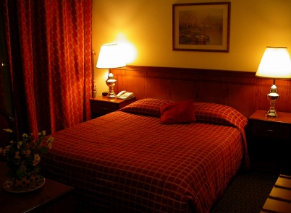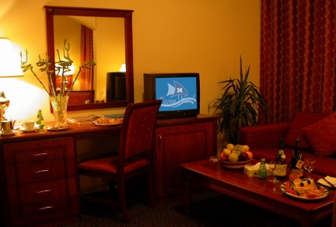
Hotel Accommodation: 48 rooms including 6 junior suites, and 6 family suites.
55 JOD | Standard Single Room On B/B Basis
70 JOD | Standard Double Room On B/B Basis
95 JOD | Junior Suite On B/B Basis
180 JOD | Family Suite On B/B Basis
Kindly note that
- The above rates are per Room on B/B basis in Jordanian Dinars and including all tax.

65 JOD | OCEAN Single Room On B/B Basis
95 JOD | OCEAN Double Room On B/B Basis
Kindly note that
- The above rates are per Room on B/B basis in Jordanian Dinars and including all tax.
- Free Coffee and Tea Kit.
- Free Soft Mini Bar& Free unlimited internet access.

Food & Beverage:
Diwan Alsultan Ibrahim restaurant & garden with a very classic and classy atmosphere run by Lebanese staff, Katz bars. Our services also include a 24- hour room service,
Reservation:
For reservation please contact us at the following address:
Reservation direct number: +962 6 5517280 – 81 – 82 - 83
Reservation direct fax: +962 6 5517380
Email: info@oceanhotel.com.jo

Web Site: www.oceanhotel.com.jo

